Heritage Impact Statement

Alterations and additions to a dwelling house and new garage

At

187 Milton Street Ashbury

Located in The Ashbury Heritage Conservation Area

Introduction:
Author: William Daskalopoulos
Prepared by William Daskalopoulos Consultant Building Surveyor and Planning Consultant 40 years experience as a Building Surveyor and designer of dwelling houses in Heritage Conservation Areas working mainly in the inner west of Sydney.
Have designed additions to many properties over the past 40years in the inner suburbs of the city. In particular have designed additions to two other houses in the vicinity of the subject property at 156 Milton Street and also a new house at 160 Milton Street Ashbury
Experience as an owner builder restoring a Californian Bungalow in a Heritage Conservation Area in the inner west at 22 Hampden Street Ashfield .
I have designed building additions in the Ashbury Heritage Conservation Area, Haberfield Heritage Conservation Area and the Paddington Heritage Conservation Area.

Sit identification and locality:

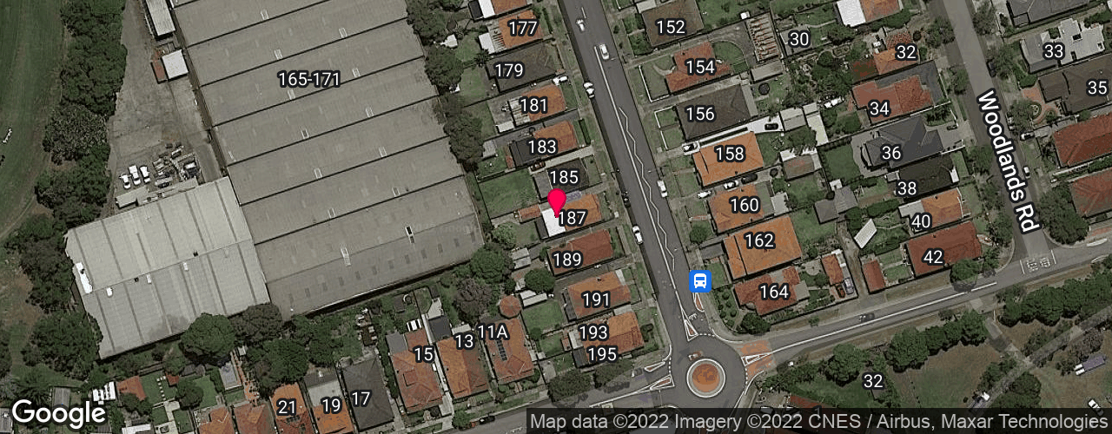
Location Plan

187 Milton Street Ashbury

General Information:

Lot 2 DP 310344
The property is rectangular in shape has a frontage of 10.975 m with a depth of 33.53 m and site area of 367.9m2 by calculation.
The land is in an R2 zone and is on the western side of Milton Street near the corner of King Street.
The proposed development involves the demolition of a fibro addition of the dwelling house and construction of an addition containing a laundry,bathroom, new kitchen , living room, rear deck on the ground floor level. A WC and storeroom in lower(basement ) level. Demolition of a fibro garage and construction of a brick garage
There is existing vehicular access to the rear of the property to the proposed garage.
The existing house has a gross floor area of about 100.8 m2 and this will increased to 177m2.
The existing FSR is 0.27 :1 = 100.82 m2 GFA. Proposed FSR 0.48:1 =. 177m2 GFA
The adjoining properties to the north and south are single storey brick houses.
Zone =R2 - The proposed development is permissible in the zone.
Conservation Area = Yes.- Ashbury Heritage Conservation Area
Heritage Item = No
Acid sulphate soils = class 5 - minimal excavation about 1m into ground and no swimming pool proposed
Flood Affected = No
Air craft noise = No
Height - 8.5m max allowed height- proposed height is 6.0m.

Existing building façade to remain as is.

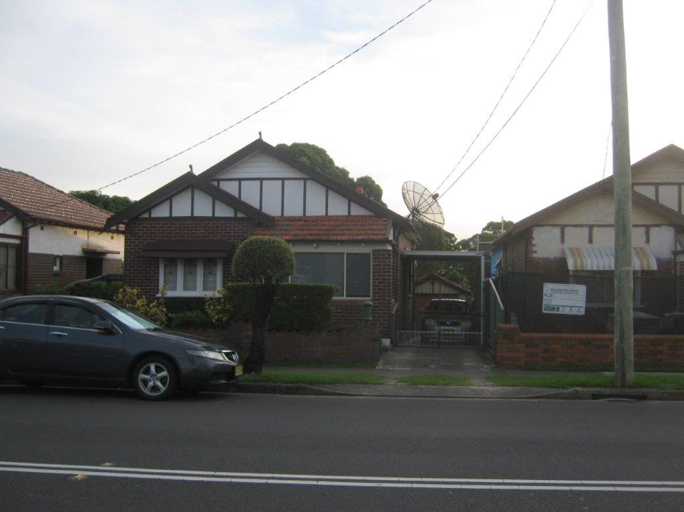

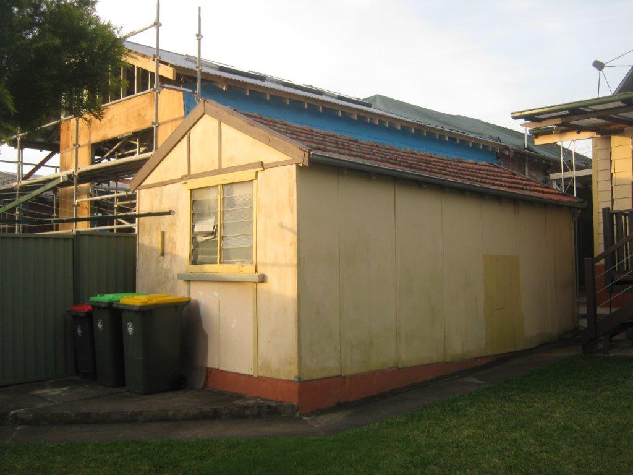

Fibro Garage to be demolished showing addition under construction at 185 Milton Street Ashbury to the north

Statement of significance and Core heritage values

Streetscape

Assessment of Heritage Impact

Planning Controls

Canterbury Local Environmental Plan (CLEP)2012

Clause 5.10
5.10 Heritage conservation
(1) Objectives The objectives of this clause are as follows—
(a) to conserve the environmental heritage of Canterbury,
(b) to conserve the heritage significance of heritage items and heritage conservation areas, including associated fabric, settings and views,
(c) to conserve archaeological sites,
(d) to conserve Aboriginal objects and Aboriginal places of heritage significance.
(2) Requirement for consent Development consent is required for any of the following—
(a) demolishing or moving any of the following or altering the exterior of any of the following (including, in the case of a building, making changes to its detail, fabric, finish or appearance)—
(i) a heritage item,
(ii) an Aboriginal object,
(iii) a building, work, relic or tree within a heritage conservation area,
(b) altering a heritage item that is a building by making structural changes to its interior or by making changes to anything inside the item that is specified in Schedule 5 in relation to the item,
(c) disturbing or excavating an archaeological site while knowing, or having reasonable cause to suspect, that the disturbance or excavation will or is likely to result in a relic being discovered, exposed, moved, damaged or destroyed,
(d) disturbing or excavating an Aboriginal place of heritage significance,
(e) erecting a building on land—
(i) on which a heritage item is located or that is within a heritage conservation area, or
(ii) on which an Aboriginal object is located or that is within an Aboriginal place of heritage significance,
(f) subdividing land—
(i) on which a heritage item is located or that is within a heritage conservation area, or
(ii) on which an Aboriginal object is located or that is within an Aboriginal place of heritage significance.
(3) When consent not required However, development consent under this clause is not required if—
(a) the applicant has notified the consent authority of the proposed development and the consent authority has advised the applicant in writing before any work is carried out that it is satisfied that the proposed development—
(i) is of a minor nature or is for the maintenance of the heritage item, Aboriginal object, Aboriginal place of heritage significance or archaeological site or a building, work, relic, tree or place within the heritage conservation area, and
(ii) would not adversely affect the heritage significance of the heritage item, Aboriginal object, Aboriginal place, archaeological site or heritage conservation area, or
(b) the development is in a cemetery or burial ground and the proposed development—
(i) is the creation of a new grave or monument, or excavation or disturbance of land for the purpose of conserving or repairing monuments or grave markers, and
(ii) would not cause disturbance to human remains, relics, Aboriginal objects in the form of grave goods, or to an Aboriginal place of heritage significance, or
(c) the development is limited to the removal of a tree or other vegetation that the Council is satisfied is a risk to human life or property, or
(d) the development is exempt development.
(4) Effect of proposed development on heritage significance The consent authority must, before granting consent under this clause in respect of a heritage item or heritage conservation area, consider the effect of the proposed development on the heritage significance of the item or area concerned. This subclause applies regardless of whether a heritage management document is prepared under subclause (5) or a heritage conservation management plan is submitted under subclause (6).

Comment; The proposed development is sympathetic to the style and character of the existing dwelling house and is similar in size to the current development at 185 Milton Street Ashbury. The proposed development was based on the scale of the approved development on the above property.

To the west is a multi unit development recently approved for two storey buildings.

The effect of the proposed development on the Heritage Conservation Area considered minimal as the scale, external material and appearance is sympathetic to the streetscape
See discussion below

Canterbury DCP 2012

Part 8.4
The controls in this section supersede all other controls if there is an inconsistency and the latter controls would result in uncharacteristic or incompatible development in Ashbury.

Background and Historical Relevance of Ashbury HCA Ashbury is a predominantly residential area that was largely developed between 1912 and 1940, with most development occurring during the Inter-War period and particularly during the building boom of the 1920s. Ashbury developed as part of the overall suburban expansion of Sydney that occurred along train lines and major roads. The area has a consistent subdivision pattern, building form and streetscape; largely because its development occurred over a relatively short period of time. A high standard of design and residential amenity was also achieved, and housing in this area has become increasingly sought after. Ashbury is experiencing significant development pressures, particularly by residents seeking to expand and/or adapt older houses to meet modern living requirements, or to build replacement houses. Some developments have been out of place with the special character of this area. At the same time there has also been a demonstrable move towards adapting and restoring existing houses in a sympathetic manner. Figure B8.1: Ashbury Heritage Conservation Area shown hatched (extract from LEP Heritage Map) Heritage B8 Canterbury Development Control Plan 2012

Elements of Ashbury’s character include:

• Street and subdivision pattern of small to medium sized, predominantly rectangular shaped allotments reflecting each phase of early twentieth century subdivision.

Comment : No subdivision is proposed

• Generally consistent built form, mostly comprising single storey detached houses in Federation, California Bungalow, and other Inter-War housing styles.

Comment: California Bungalow style to be maintained

• Predominance of California Bungalow type houses resulting in many street façades composed of the following architectural elements: ⋅ Double or triple fronted gables facing the street; ⋅ Semi-enclosed front porch or veranda; ⋅ Bay windows; ⋅ Asymmetrical façade composition; and ⋅ Architectural expression of the base (rendered brick or roughly hewn stone base course), middle (face brick) and top (battening and barge boards).

Comment: No change to street facade

• Houses in a landscaped setting. Gardens have extensive shrub and tree planting with low garden walls and fences, and are generally well maintained. • Extensive street tree planting often typical of the Federation and Inter-War period.

Comment: Landscaped setting is maintained no change to front fence or facade

The proposed development to the dwelling house is subservient and sympathetic to their form, materials and style. In particular external materials and finishes will match the existing The proposed garage is subservient to the dwelling house, is at the rear of the property in the usual preferred location in the Ashbury Conservation Area.
The proposed additions cannot be characterized as dominating the existing dwelling house as shown in the example in Figure B8.3: of Canterbury DCP- Substantial two storey additions that dominate existing houses and the street and erode the special character of Ashbury.

Part B8.1 General Objectives

O1 To conserve the environmental heritage of Canterbury.
Comment: Complies

O2 To ensure changes to places of heritage significance are in accordance with the heritage conservation process, and the design principles set out in this DCP.

Comment: Complies

O3 To ensure the significant fabric, materials and finishes, visual setting, landscape elements, fencing, and other contributory elements of places of heritage significance are conserved.

Comment: Significant fabric materials and finishes visual setting, landscape elements, are conserved

O4 To ensure that new fabric, materials and finishes, visual setting, landscape elements, fencing, and other elements are complementary to places of heritage significance.

Comment: Materials and finishes visual setting, landscape elements, are complementary

O5 To require that development on land in the vicinity of a place of heritage significance is designed in a way that is compatible with the character of the place of heritage significance.

Comment: Not near any heritage Items

The alterations and additions maintain the single storey appearance of the dwelling when viewed from the street
The fibro garage contains asbestos as such will be replaced with a brick garage with external materials matching the dwelling house.
Paving will be removed from the rear yard and replaces with soft landscaping

Designs Options
The proposed design was selected as it would provide an improved living area at the rear of the dwelling house to cater for the needs of the owner’s family and it would improve solar access to the northern side of the living area of the house while not impacting on the existing character of the house and the streetscape.

The proposal also follows the scale of the development under construction next door at 185 Milton Street Ashbury but has a rear hip roof form instead of a gable.

The building work will only be partly visible from the street given that it is lower than the existing roof.

Positive and negative effects :
The positive effects will be the improved solar access to the living areas in winter.
There will be no real negative effects on any nearby property or on the subject property.

Conservation Principles:
The proposed work will not affect the main fabric of the house and the work will only be partly visible from the street. The addition will be constructed of materials which are sympathetic to the features of the existing dwelling house.

The proposed development is to the rear of the brick dwelling house and is low in scale as such has minimal impact on the existing dwelling house and its setting.
External materials and finishes will be timber framed windows, dry pressed face bricks, Sydney red unglazed French pattern Monier roof tiles with Manor Red colorbond finish to gutters, new bricks will be Bowral Murray Gray. The new roof on the dwelling house will be stepped down 300mm from the existing ridge. The materials and the design of the development are sympathetic to the style and character of the Californian bungalow dwelling house on the property. The dwelling house on the land was constructed after about 1927.

There is vehicular access on the northern side of the property and the proposed garage is to the rear as is typical for garages in the Heritage Conservation Area.

The scale of the proposed garage does not compete with the style and scale of the dwelling house. The proposed garage will provide for one car parking space and space for bicycles. The garage has a floor area of 20.5m2. The size of the garage is far less than the maximum size allowed for this type of structure under the Canterbury DCP.

Open Space
The proposed open space will be reduced by the proposed development however the soft landscaping will be improved. The proposed FSR and open space complies with council’s controls. Open space is consistent with the new development at 185 Milton Street Ashbury

Conclusion
The proposed development is in keeping with the style and character of the existing dwelling house and satisfies the objectives of the LEP and DCP as such it is worthy and suitable for approval by Council.

